
Procedure 2025

ArcelorMittal Building Solutions France

Procedure 1.1.1.12

Costumer follow-ups

Software used : Sofie/SAP/Relances Clients


1.Issue a balance on SAP :

- On SAP

Go to the variant, then remove "Created by" :

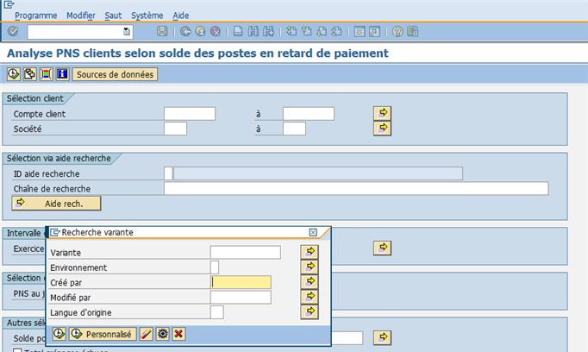

Then Execute

Select Balance group 2 + Balance AG HG + 180d :

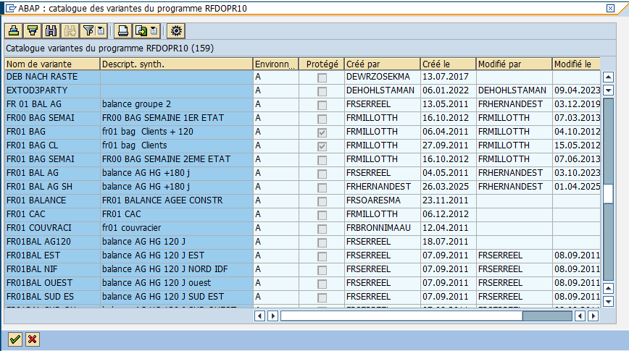

Change date, indicate current date + check that there are two assets :

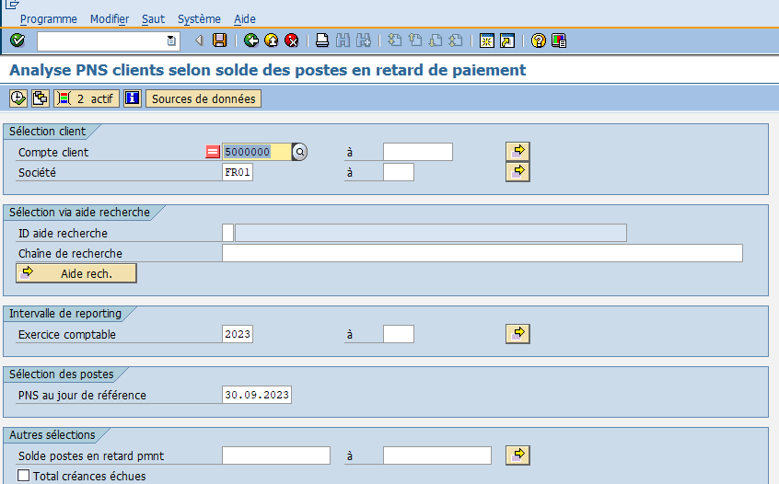

Verify the accuracy of the payment schedule :

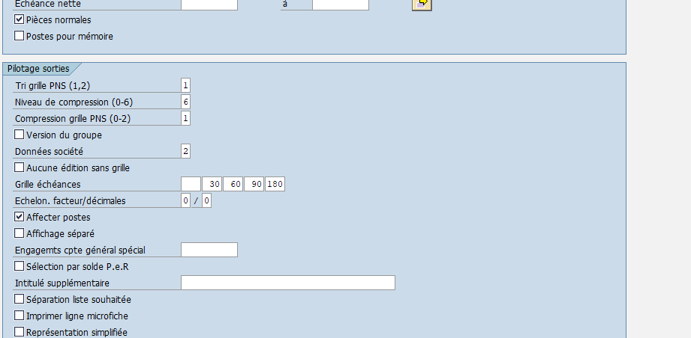

Then F8

- Export balance to Excel

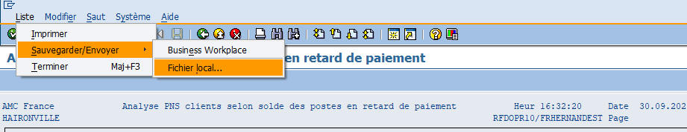

Calculation with spreadsheet :

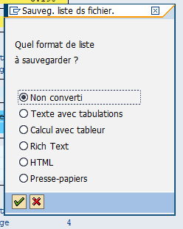

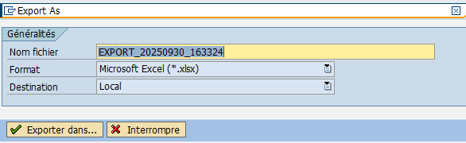
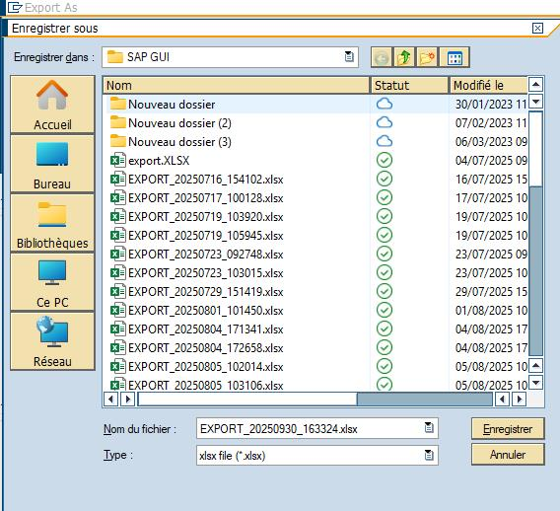

- Formatting the Excel sheet

Delete the first column of the sheet :

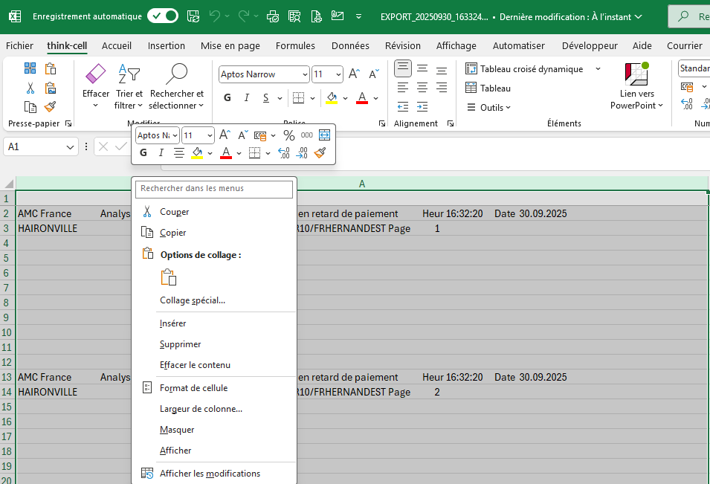

Delete the first blank rows of the sheet :

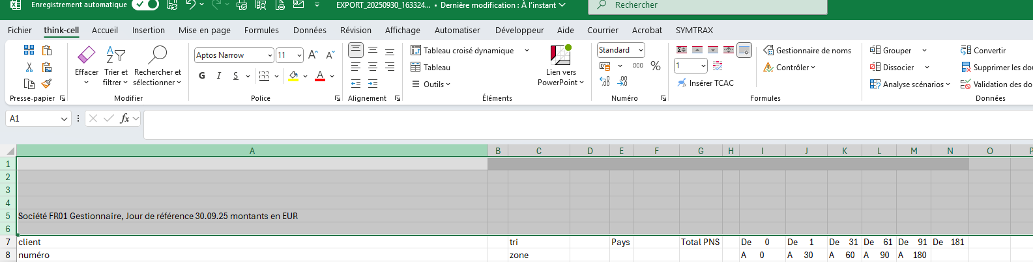

Convert all columns containing figures : Data > Convert > Next > Next > Finish

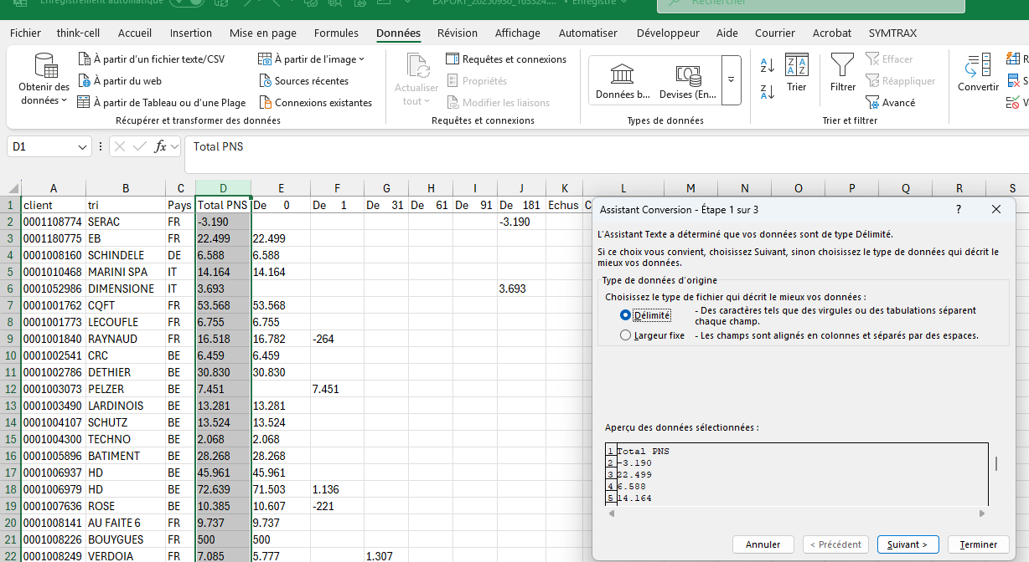

Add the "Overdue" and "Comments" columns :
The "Overdue" column must contain the formula = D-E (Total PNS - 0)

Then save the file in K "Balance pour relance" and rename the file "BAL HG date" :

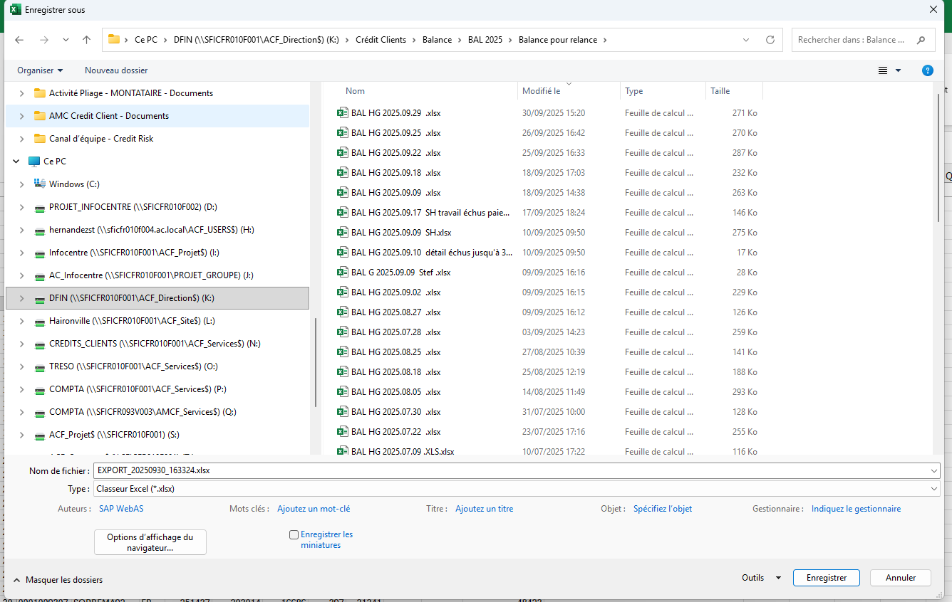

2. Follow up with customers :

- Process the table line by line :
Exemple : We're on the « FUSION CONSTRUCTION » customer, and we can see that he has €13,763 overdue

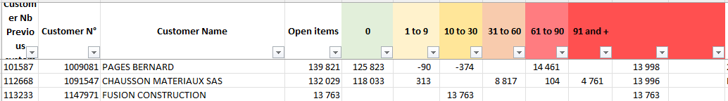

- Go to the customer dunning history :

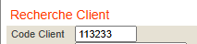 Enter SOFIE code
Click on outstanding invoices :
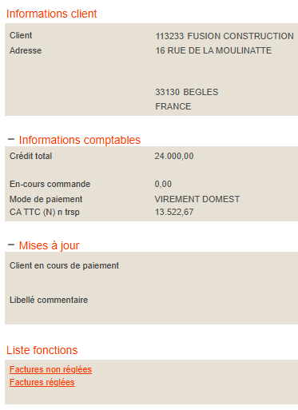

In this tab, you’ll find all the invoices, including those that are are overdue :
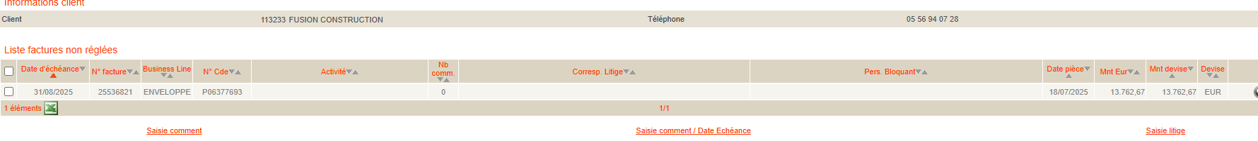

It is therefore necessary to perform customer follow-ups and accounting controls.

- Contrôl in SAP

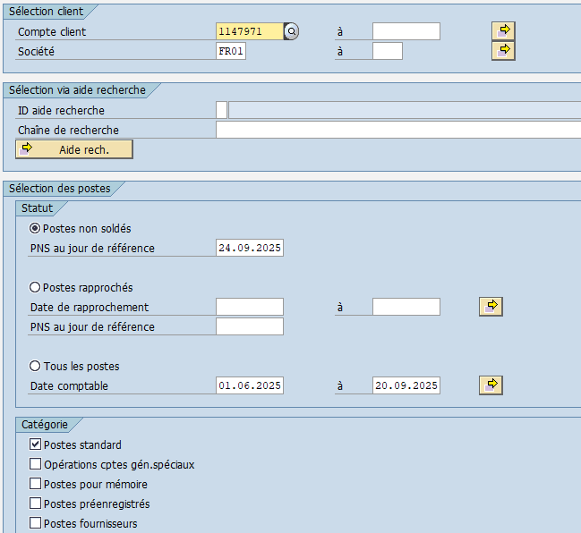

Enter the above data, then F8 or Execute

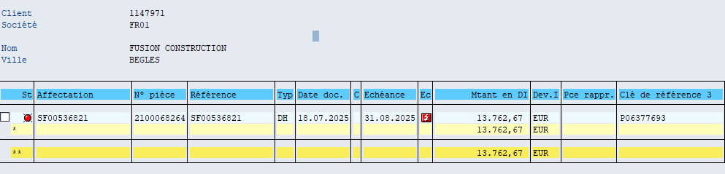

We note that this invoice has not been paid and has been overdue since 08/31/2025.

- Find the contact to follow up with

Search for an e-mail address in SOFIE or in the customer reminder.

03-01-05-01, then enter the SOFIE code.
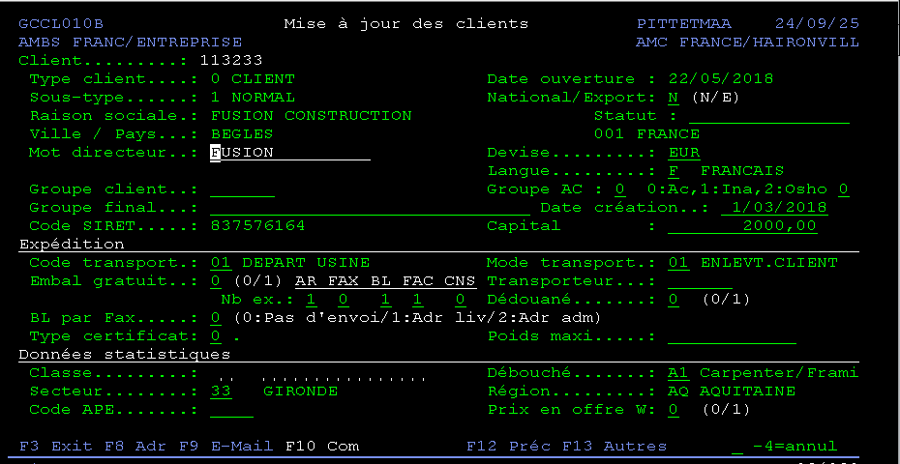

Press F9,
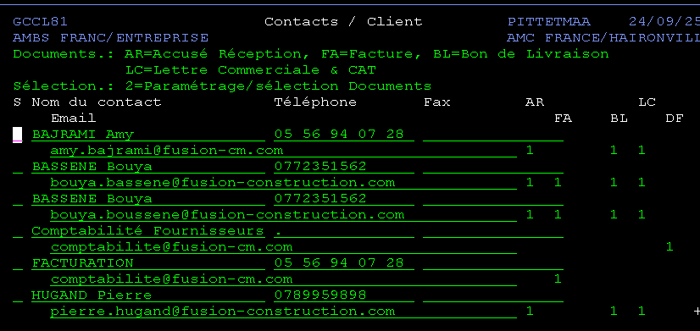

If several contacts are listed, use the email address “Accounting”, “Collections”, “Suppliers”, or any email address related to invoice payments.

- Send the reminder e-mail to the customer and monitor the responses.

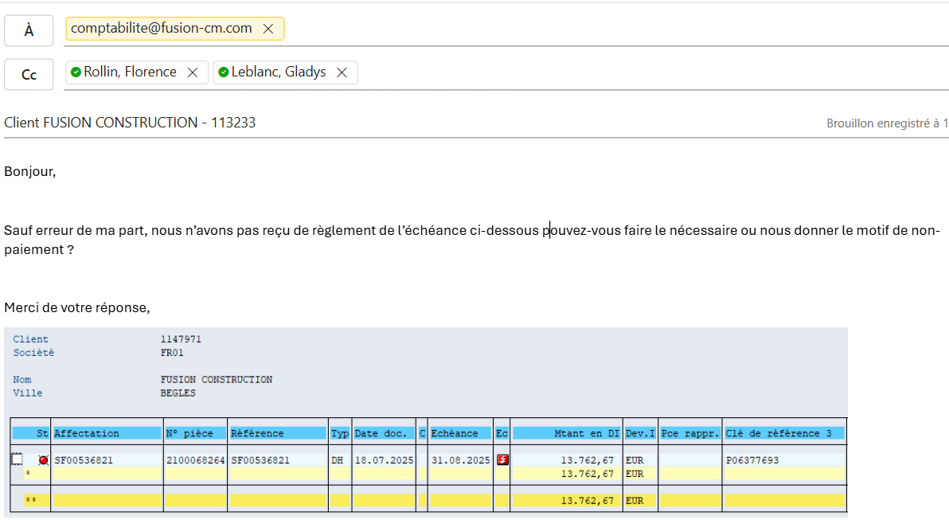

- Dunning history

Go to customer dunnig
Tick the boxes for dunned invoices

Then enter comment / Due date

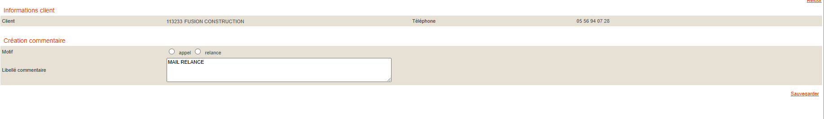
Write down what we've done and the various follow-ups « FOLLOW-UP EMAIL » the save.

Go to Excel balance and add comments 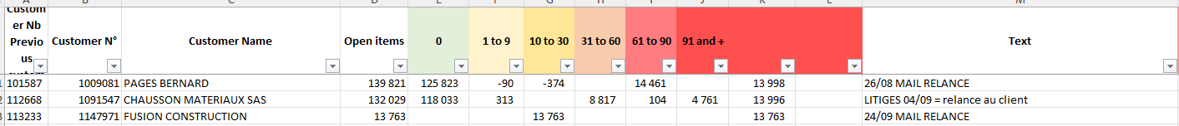

Save the dunning mail under N
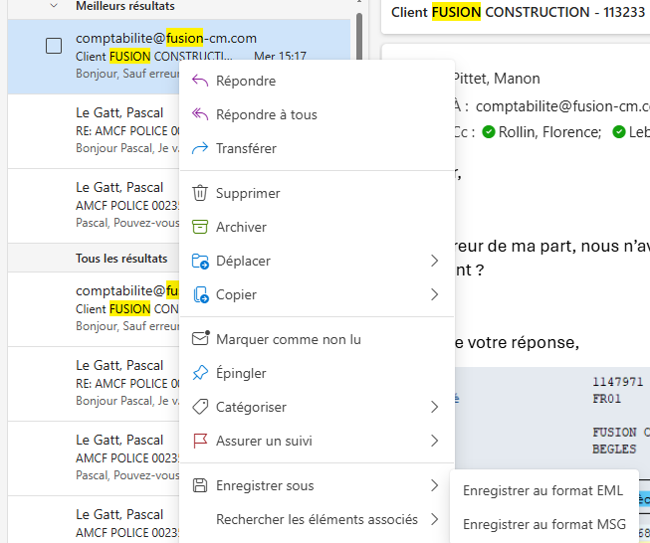

Right-click, save as, then save in MSG format.

Save in the customer file under N in the "Relances Recouvrement" folder.

18/11/2025
Procedure validated by : S. HERNANDEZ
